**DECENTRALIZED TRACEABILITY AND DIRECT MARKETING OF AGRICULTURAL SUPPLY CHAIN**

Narasimhulu.M,1, a)  Shabana.S , Sai Charan Reddy.N, Sai pranav reddy.G, Sushmitha.C 2,3,4,5b)

*1Assistant Professor, Computer Science and Engineering, Srinivasa Ramanujan Institute of Technology, Anantapur, India.*

*2,3,4,5Computer Science and Engineering, Srinivasa Ramanujan Institute of Technology*

*a)*[*narasimhulu.cse@srit.ac.in*](mailto:narasimhulu.cse@srit.ac.in)*,*

*b)*[*204g1a0595@srit.ac.in*](mailto:204g1a0595@srit.ac.in)

*c)*[*204g1a0584@srit.ac.in*](mailto:204g1a0584@srit.ac.in)

*d)*[*204g1a0590@srit.ac.in*](mailto:204g1a0590@srit.ac.in)

*e)*[*214g5a05A6@srit.ac.in*](mailto:214g5a05A6@srit.ac.in)

**Abstract:** The agriculture sector is facing the major challenges because of the absence of direct supply chain between farmers and buyers. This will lead to vulnerabilities, reduce the farmers income and compromises product quality. To address these issues, we are developing a web portal which facilitates the visibility of farmers profiles making their details accessible to the wide range of buyers. This approach lets buyers to connect with farmers through the portal, allowing them to negotiate and quickly update price agreements.

To enhance transparency and security, our system incorporates Blockchain technology to record and securely store all transactions. Our innovative web portal strives to bridge the gap between farmers and buyers promoting transparency and trust in agriculture transactions. This approach has the potential to benefit both farmers and consumers while promoting sustainable practices within the agricultural sector.

Food safety and corruption hazards have necessitated the implementation of effective traceability measures to ensure product safety throughout the agricultural supply chain. Blockchain technology has emerged as a revolutionary system capable of providing groundbreaking solutions for commodity traceability in both agriculture and food supply chains. By leveraging blockchain's immutable and decentralized ledger, stakeholders across the supply chain can securely record and track every stage of production, processing, and distribution. This transparency and accountability enable swift identification and mitigation of risks, safeguarding the integrity and safety of agricultural products from farm to fork.

**Keywords : Agriculture supply chain, Direct marketing, Blockchain, Traceability.**

# 

# INTRODUCTION

In today's world, the agriculture supply chain faces numerous challenges, including transparency, traceability, and direct marketing.Farmers struggle to find reliable buyers for their crops, and buyers face challenges in sourcing quality products at fair prices. The farmers get less price than the minimum selling price in the market because of many intermediaries present in the current supply chain. There is no clear and reliable record about the crop, origin, quality, and the final price. There is no direct communication and negotiation between the farmer and the buyer. Lack of transparency in transactions makes it difficult for the farmer and the buyer to trust each other leading to disputes.

To address these issues, our project focus on the development of a decentralized traceability and direct marketing system for agriculture supply chains. This innovative system empowers buyers, sellers, and administrators, fostering a more efficient and transparent marketplace. Buyers can seamlessly register, log in, and access detailed information about sellers' crops, enabling them to make informed decisions. They can also send requests to sellers, view responses, make payments securely, and log out, ensuring a user-friendly experience.Sellers, on the other hand, can register and log in to provide comprehensive crop information, view buyer requests, and track payments effortlessly. This system streamlines the marketing process for sellers, improving their reach and efficiency. Administrators have the capability to log in, manage fixed payments, and maintain the system's integrity. Our decentralized traceability and direct marketing system promise to revolutionize agriculture supply chains, enhancing transparency, trust, and efficiency across the industry.

**LITERATURE SURVEY**

[1] The implementation of a blockchain-based strategy within the agricultural supply chain is poised to revolutionize operations pertaining to tracking crop prices and ensuring traceability. This proposed framework eliminates the necessity for trusted centralized authorities and intermediaries, thereby streamlining business operations.

[2] authors have presented an approach aimed at enhancing the traceability of soybeans within the Agri-Food supply chain. Their proposed solution addresses issues associated with centralized systems while eliminating the reliance on trusted third parties. This approach prioritizes maintaining high levels of integrity, trustability, and security throughout the supply chain processes.

[3] Given the escalating concerns surrounding food safety in both commercial and academic spheres, the centralization of existing systems has become increasingly problematic, leading to issues such as fraud, tampering, and vulnerability to man-in-the-middle attacks.

[4] An author has proposed a traceability scheme integrating Hazard Analysis and Critical Control Points (HACCP), blockchain, and Internet of Things (IoT) technologies, aiming to address these challenges comprehensively.

[5] the authors propose an effective warehousing scheme tailored for Agri-Food product tracking. They employ the InterPlanetary File System (IPFS) in conjunction with a secondary database to facilitate traceability. IPFS functions as a network for decentralized storage and sharing of data within a distributed file system. To retrieve data from IPFS, the sale hash is extracted from the secondary database.

[6] an auditable protocol designed to ensure transparency, tamper-evidence, and empirical transactions among stakeholders. Leveraging the Ethereum blockchain, the protocol supports online supply chain systems, particularly in the Business-to-Consumer (B2C) model.

[7] The authors stress the importance of transparent, tamper-proof, and adaptable tracing of product provenance within the supply chain. To address these requirements, they introduce an innovative solution called the origin-chain, leveraging both private and public blockchain technologies.

[8] Another group of authors presents a blockchain-based decentralized traceability process and offers a corresponding case study. Their use case illustrates the traceability of products from their origin to the consumer's table, demonstrating the efficacy of different performance platforms such as Ethereum and Hyperledger.

# PROPOSED SYSTEM

The proposed system aims to establish a decentralized traceability and direct marketing platform for agricultural supply chains. Buyers can easily access the system through registration and login, enabling them to view seller crops, send requests, and make payments seamlessly. Sellers, after registering and logging in, can provide crop information, view buyer requests, and track payments received. Additionally, the system empowers the admin to log in, manage fixed payments, and ensure smooth operations. This platform enhances transparency, efficiency, and trust within the agriculture supply chain, promoting fair and direct interactions among stakeholders.

MATERIAL AND METHODOLOGY

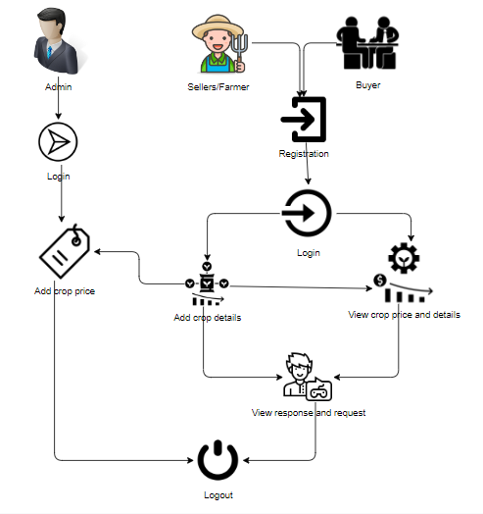

**FIGURE 1.Block diagram for suggested approach**

# Methodology Overview

The flow diagram that follows provides an explanation of how the system operates. The steps that make up the overall process areas follows.

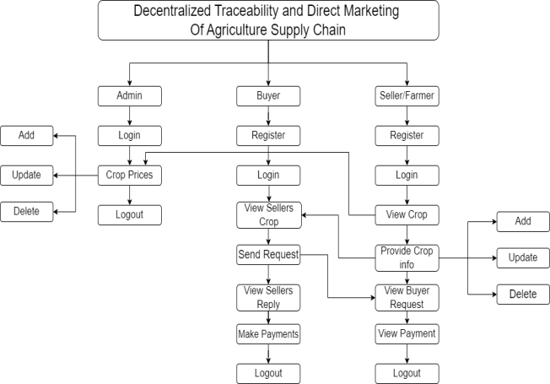

**FIGURE 2. Flow diagram for suggested approach**

**System Implementation**

**Modules:**

To develop a decentralized traceability for agriculture supply chains, you can break down the functionality into several modules for the different user roles: Buyer, Seller, and Admin. Here are the modules for each role:

Buyer:

**1. Register:** The buyer will register with their details like name, email, password, address, contact, so after that the buyer will login.

**2. Login:** After registration the buyer will login with their details.

**3. View Seller's Crop Information:** Once the sellers will add the details the buyer can view those details here.

**4. Send Request to Seller:** If the buyer wants the details of crop then buyer will send request to seller.

**5. View Seller Requests:** Displays responses from sellers to the buyer's requests.

**6. Make Payment:** Once the seller accept the request for the crop the buyer has to pay the amount for that crop.

**7. Logout:** Allows buyers to logout securely.

Seller:

**1. Register:** The seller will register with their details like name, email, password, address, contact, so after that the seller will login.

**2. Login:** After registration the seller will login with their details.

**3. Provide Crop Information:** The seller will add there crop details like (crop name, crop category, and quantity and quality).

**4.View Buyer Requests:** When the buyer will send the request for the crop, here the buyer will view and he/she has to accept the request.

**5. View Payments:** Once the buyer will pay the amount for the crops. The seller can view the details of the payment.

**6. Logout:** Allows sellers to logout securely.

Admin:

**1. Login:** The admin will login with default email and password.

**2. Crop price:** The admin is the person he/ she will add the crop price for each and every crop details with that crop name, category, maximum cost, minimum cost and quantity.

**3. Logout:** Allows the admin to log out securely.

A sequence illustration is a kind of commerce illustration that shows how processes operate with one another and in what order. It's a construct of a Communication Sequence Map.

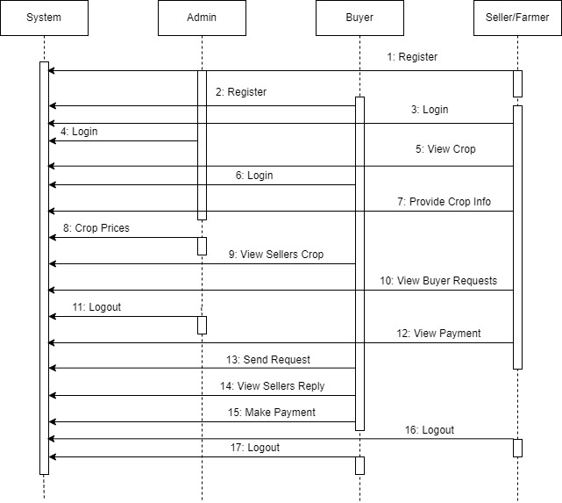

**FIGURE 3 . Sequence diagram**

The main purpose of a use case illustration is to show what system functions are performed for which actor. places of the actors in the system can be depicted.

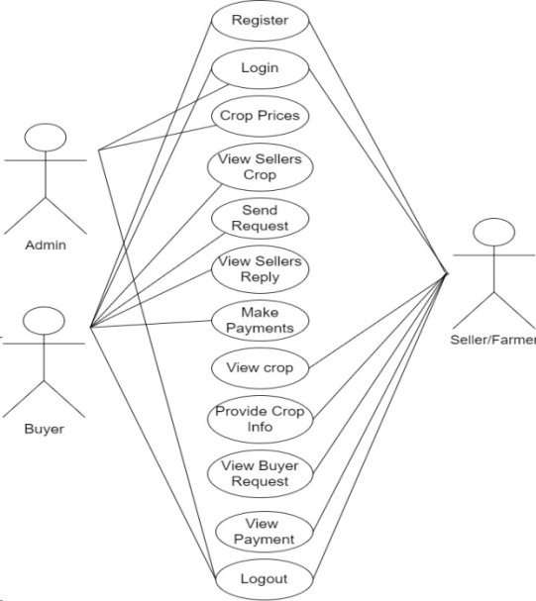

**FIGURE 4 .Usecase diagram**

# EXPERIMENTS AND RESULTS

Given that we are using a web page to demonstrate how the system functions. The outputs from the first to the last step,or from the registration stage to the payment viewing stage, are displayed in the photos below. Admin can login and set minimum cost price for the crops. Sellers can register, login, provide crop details and accept the requests of buyers for payment process. Buyers can also register, login, view the crop details, send request to sellers for payment.

Home: this is the initial page of the project

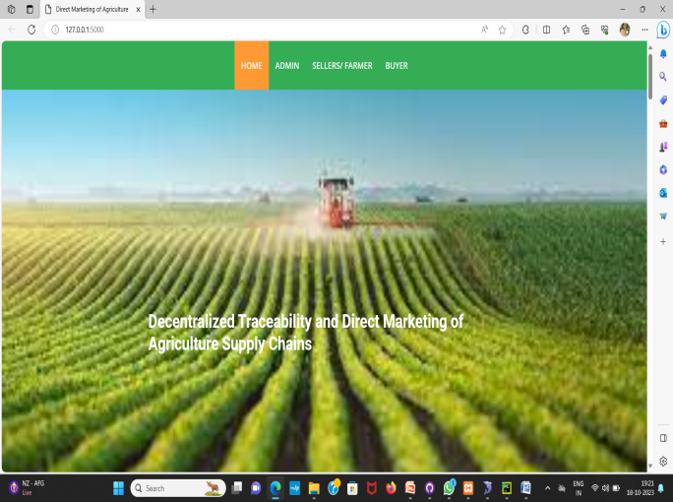

**FIGURE 5. Home Page**

User Registration:

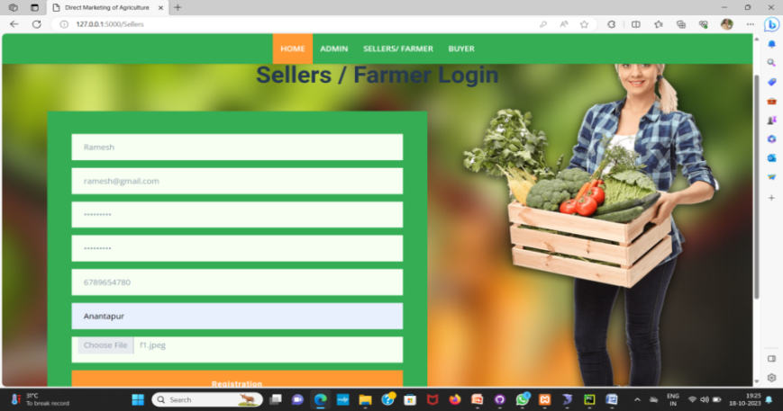

**FIGURE 6. Registration page**

User login:

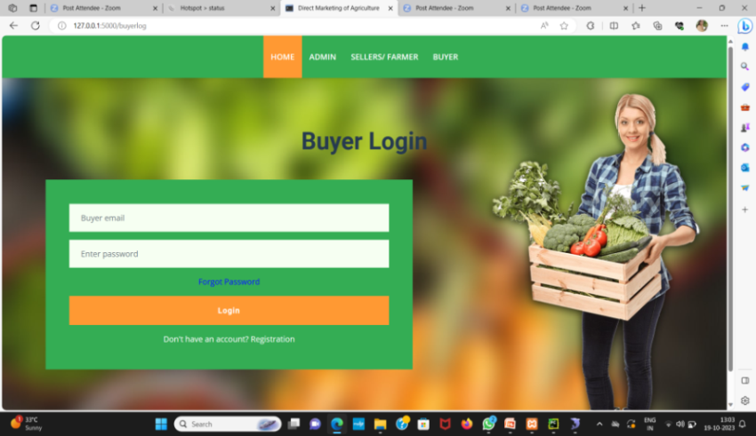

**FIGURE 7. Login Page**

Adding crop information

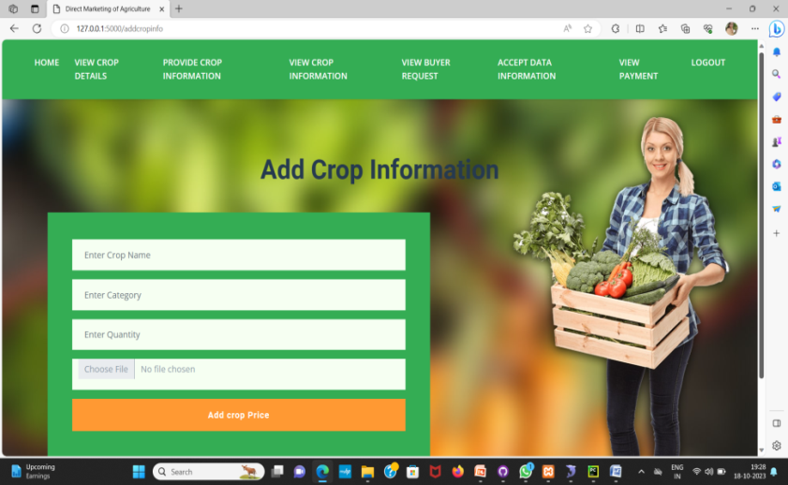

**Figure 8 . Seller adding crop details**

View Crop Information:

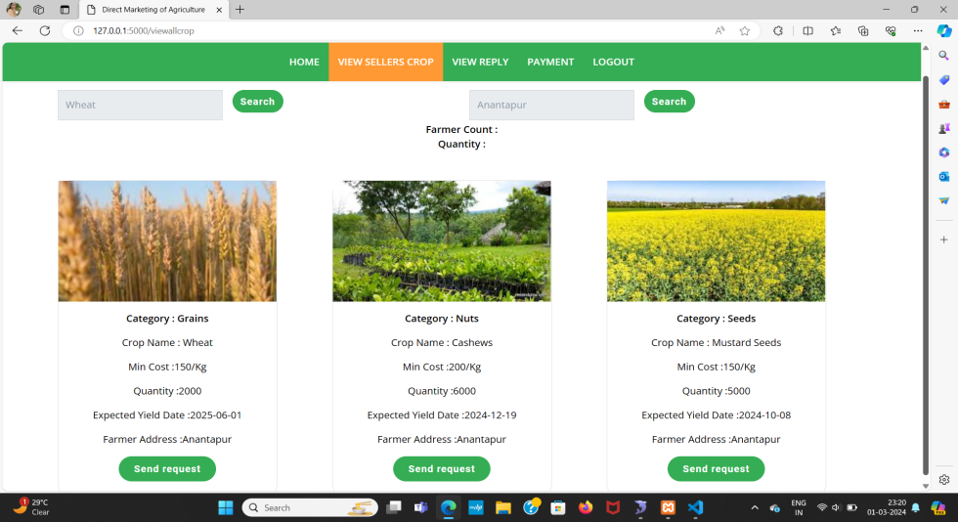

**FIGURE 9. Buyer Viewing crop details**

Sending Request:

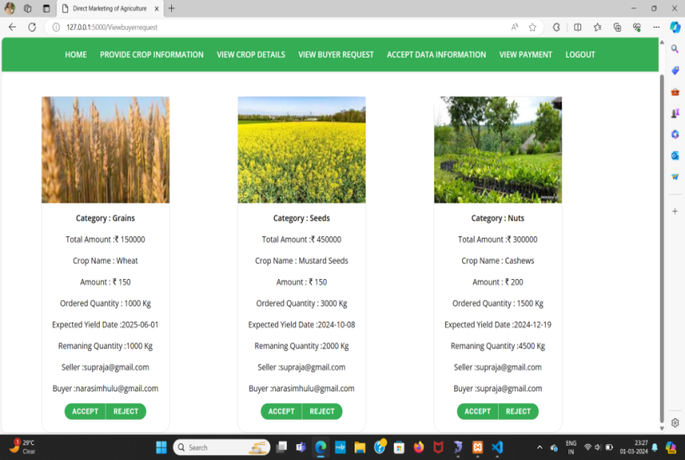

**FIGURE 10.Sending request to seller**

View Response from Sellers:

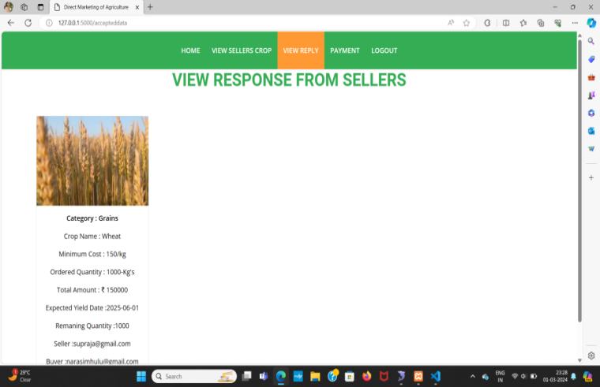

**FIGURE 11.Request Acceptance**

Payment:

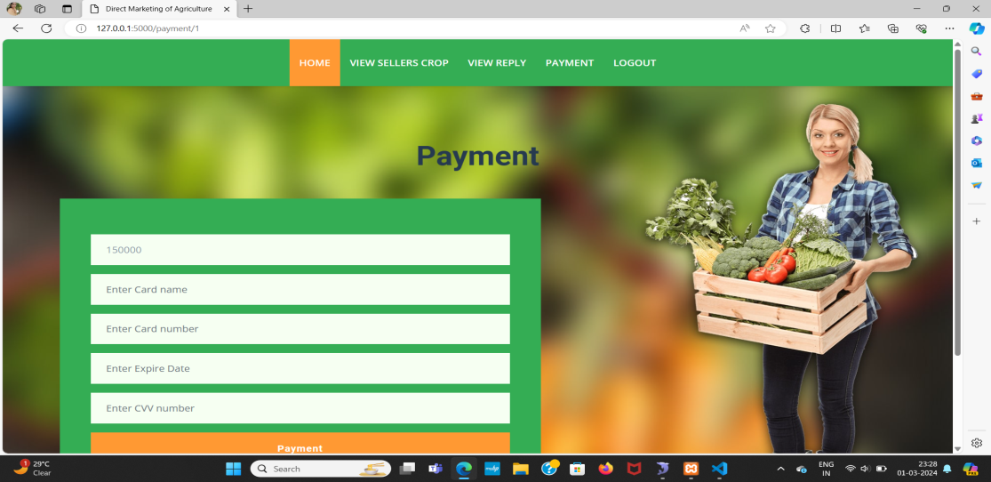

**FIGURE 12.Payment Page**

Payment Status:

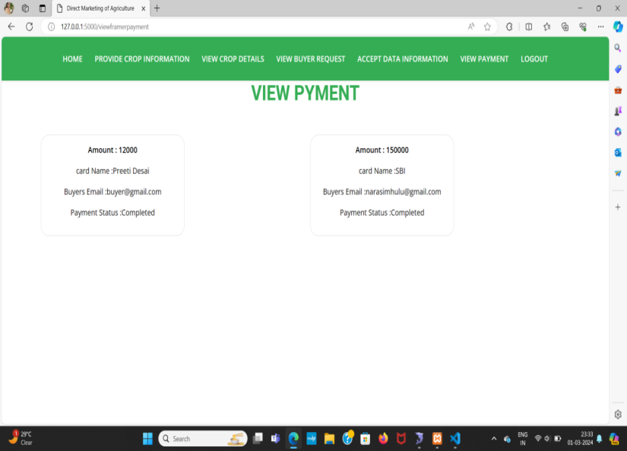

**FIGURE 13. Payment Status**

**ACKNOWLEDGEMENT**

We extend our sincere gratitude to the contributors and collaborators involved in the development of this project aimed at Decentralized traceability and direct marketing of agriculture supply chain. Special thanks are extended to the teams and researchers who pioneered the utilization of Traceability , particularly Blockchain technology. Their innovative work forms the foundation of our approach, allowing us to leverage the power of web development and Blockchain for more accurate and efficient payment process. This project would not have been possible without the collective efforts and expertise of those dedicated to advancing technology in agriculture supply chain and traceability.

**CONCLUSION**

In this paper, we proposed a Blockchain based web portal that facilitates farmers to sell their products in a transparent manner. All the data is stored in the database. There is an direct interaction between sellers and buyers which is crucial for trust and making the payment easier. This system enhance transparency, traceability and trust in the whole process.In future we can implement More security, provide Email Authentication and add rating system .

**REFERENCES**

[1] Shivendra, Chiranjeevi, Tipathi, M.K & Maktedar, [“Blockchain Technology in Agriculture Product Supply Chain](https://ieeexplore.ieee.org/document/9395886)”.

[2] K. Salah N. Nizamuddin R. Jayaraman and M. Omar, "[Blockchain-based soyabean traceability in agricultural supply chain](https://ieeexplore.ieee.org/stamp/stamp.jsp?arnumber=8718621)" IEEE Access vol. 7 pp. 73295-73305 2019.

[3] M. P. Caro, M. S. Ali, M. Vecchio, and R. Giaffreda, ‘‘[Blockchain based tarceability in agri-food supply chain management](https://ieeexplore.ieee.org/document/8373021)’’ in Proc. IoT Vertical Topical Summit Agricult.-Tuscany (IOT Tuscany), May 2018, pp. 1–4.

[4] F. Tian, ‘‘[A supply chain traceability system for food safety based on HACCP, blockchain & Internet of Things](https://ieeexplore.ieee.org/abstract/document/7996119),’’ in Proc. Int. Conf. Service Syst. Service Manage., 2017, pp. 1–6.

[5] J. Hao, Y. Sun, and H. Luo, ‘‘[A safe and efficient storage scheme based on blockchain and IPFS for agricultural products tracking,](https://www.semanticscholar.org/paper/A-Safe-and-Efficient-Storage-Scheme-Based-on-and-Hao-Sun/759117d27b07ace9d2fa58fa4b7ff6f08bc7a326)’’ J. Comput., vol. 29, no. 6, pp. 158–167, 2018.

[6] S. Wang, X. Tang, Y. Zhang, and J. Chen, ‘‘[Auditable protocols for fair payment and physical asset delivery based on smart contracts](https://ieeexplore.ieee.org/document/8792156),’’ IEEE Access, vol. 7, pp. 109439–109453, 2019

[7] Z. Li, H. Wu, B. King, Z. B. Miled, J. Wassick, and J. Tazelaar, [‘‘A hybrid blockchain ledger for supply chain visibility,](https://ieeexplore.ieee.org/document/8452028)’’ in Proc. 17th Int. Symp. Parallel Distrib. Comput. (ISPDC), Jun. 2018, pp. 118–125.

[8] Q. Lu and X. Xu, ‘‘Adaptable blockchain-based systems: A case study for product traceability,’’ IEEE Softw., vol. 34, no. 6, pp. 21–27, Nov. 2017.

[9] L. Lucas. Financial Times. (2018). From Farm to Plate, Blockchain Dishes Up Simple Food Tracking. Accessed: Jun. 12, 2018. [Online]. Available: <https://www.ft.com/content/225d32bc-4dfa-11e8-97e4-13afc22d86d4>

[10] A. Bogner, M. Chanson, and A. Meeuw, ‘‘[A decentralised sharing app running a smart contract on the Ethereum blockchain,’’](https://cocoa.ethz.ch/downloads/2017/08/2306_Sharing_App_Final_Publication.pdf) in Proc. 6th Int. Conf. Internet Things, 2016, pp. 177–178.  [

[11] D. Mao, Z. Hao, F. Wang, and H. Li, ‘‘Novel automatic food trading system using consortium blockchain[Novel Automatic Food Trading System Using consotium blockchain](https://www.semanticscholar.org/paper/Novel-Automatic-Food-Trading-System-Using-Mao-Hao/407b9b43f6eac0790b1a11148f3ef4b99d0bf7f1),’’ Arabian J. Sci. Eng., vol. 44, no. 4, pp. 3439–3455, Apr. 2018.

[12] F. Dabbene and P. Gay, ‘‘[Food traceability systems: Performance evaluation and optimization](https://ui.adsabs.harvard.edu/abs/2011CEAgr..75..139D/abstract),’’ Comput. Electron. Agricult., vol. 75, no. 2, pp. 139–146, 2011.

[13] J. Storoy, M. Thakur, and P. Olsen, ‘‘[The TraceFood framework— Principles and guidelines for implementing traceability in food value chain,](https://www.semanticscholar.org/paper/The-TraceFood-Framework-%E2%80%93-Principles-and-guidelines-Stor%C3%B8y-Thakur/23dfaf19b57e7d6d6f90c732a1f60ddd41a5d7d2)’’ J. Food Eng., vol. 115, no. 2, pp. 41–48, 2013.

[14] M. A. Khan and K. Salah, ‘‘[IoT security: Review, blockchain solutions, and open challenges](https://www.academia.edu/38066793/IoT_security_review_blockchain_solutions_and_open_challenges)’’ Future Gener. Comput. Syst., vol. 82, pp. 395–411, May 2018.

[15] J. Hobbs, ‘‘[Liability and traceability in agri-food supply chains](https://www.researchgate.net/publication/226514135_Liability_and_traceability_in_agri-food_supply_chains),’’ in Quantifying the Agri-Food Supply Chain. Springer, 2006, pp. 87–102.